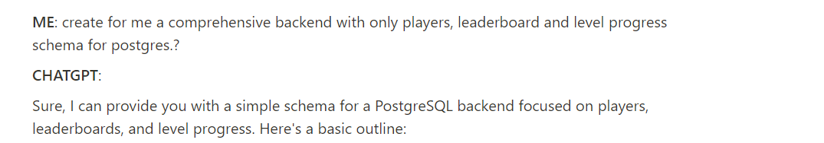

-- Create a players table to store player information.

CREATE TABLE players (

player_id SERIAL PRIMARY KEY,

first_name VARCHAR(255) NOT NULL,

last_name VARCHAR(255) NOT NULL,

email VARCHAR(255) UNIQUE NOT NULL, -- Assuming each player's email is unique.

register_date TIMESTAMP NOT NULL DEFAULT CURRENT_TIMESTAMP

);

-- Create a levels table to store game level details.

CREATE TABLE levels (

level_id SERIAL PRIMARY KEY,

level_name VARCHAR(255) NOT NULL,

difficulty VARCHAR(50) -- This is just an example; you can have more columns as per your requirements.

);

-- Create a gaming_progress table to store each player's progress in different levels.

CREATE TABLE gaming_progress (

progress_id SERIAL PRIMARY KEY,

player_id INT REFERENCES players(player_id), -- Foreign key to players table

level_id INT REFERENCES levels(level_id), -- Foreign key to levels table

score INT NOT NULL DEFAULT 0, -- Store player's score for this level

completion_date TIMESTAMP,

UNIQUE(player_id, level_id) -- Each player should have only one score entry per level.

);

-- Create a leaderboard view for quick access to top players by score for each level.

CREATE VIEW leaderboard AS

SELECT

p.first_name,

p.last_name,

l.level_name,

gp.score

FROM

players p

JOIN

gaming_progress gp ON p.player_id = gp.player_id

JOIN

levels l ON l.level_id = gp.level_id

ORDER BY

gp.score DESC, -- Order primarily by score

gp.completion_date ASC -- If scores are tied, the player who completed earlier is ranked higher.

LIMIT 10; -- Top 10 scores; adjust as required.

